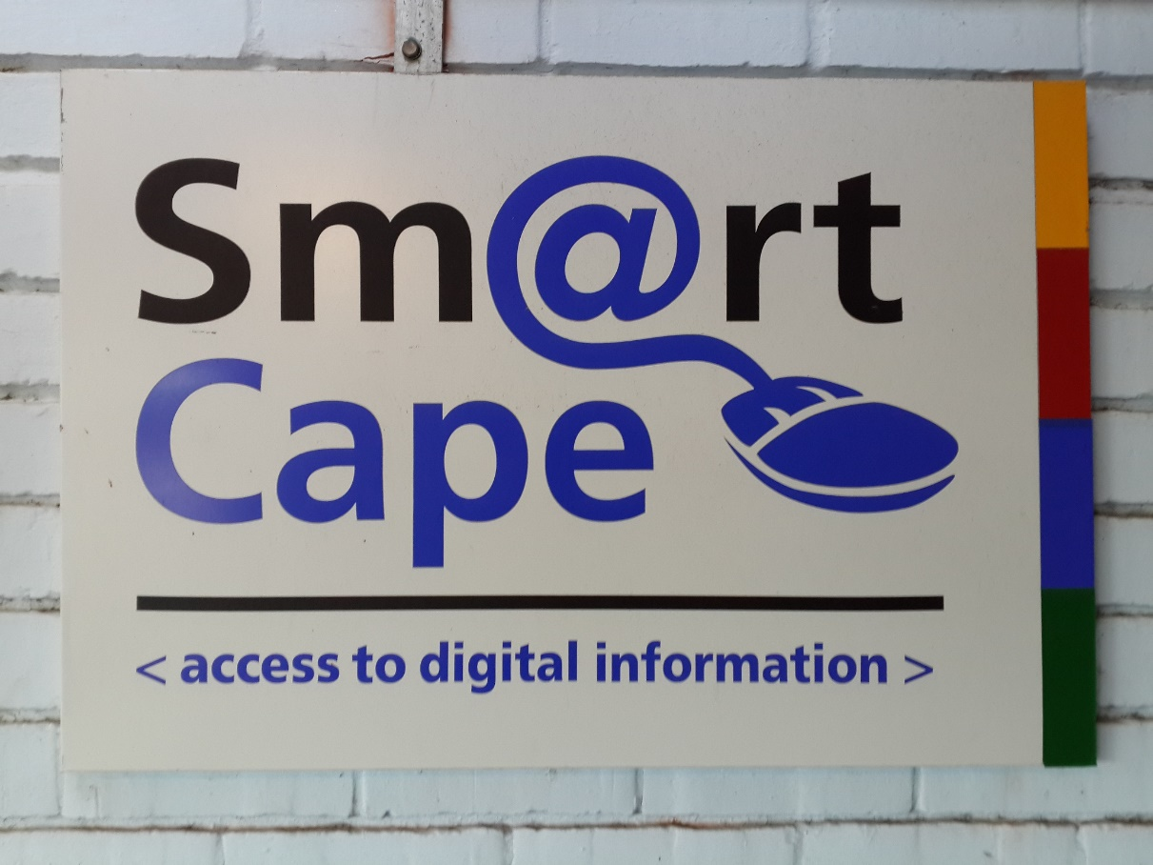

SmartCape is a platform used by libraries that gives users access to the internet. With SmartCape users need to get login details from a librarian whilst at the library.

*Get to Supreme Library where patrons are treated with the highest regard and where minds are enriched beyond bounds!*