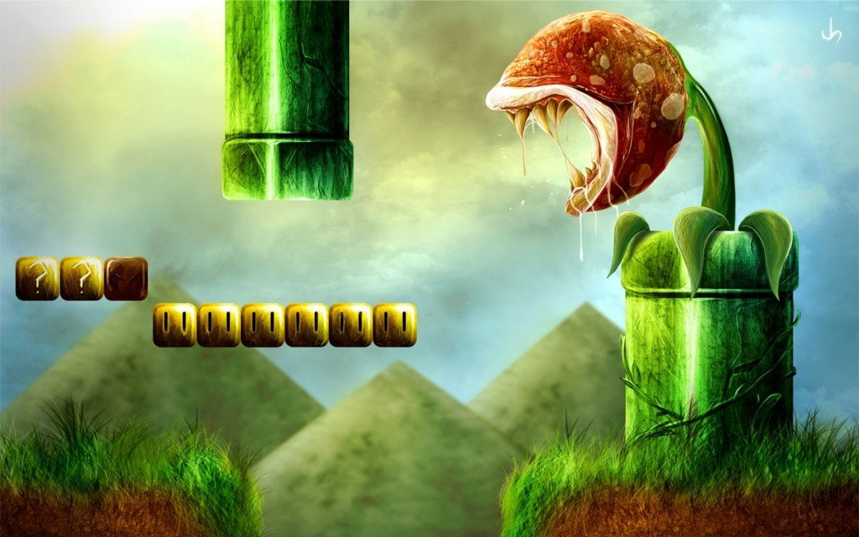

Just like you can take a book out on loan, we loan video games with the following terms and conditions:

* The video game is returned in the condition that it was given to you
* Video games are not loaned for more than 7 days due to high demand
* Patrons agree to pay a fineable fee if the video game is returned after the due date

*Come on and have some loan fun gamers!*