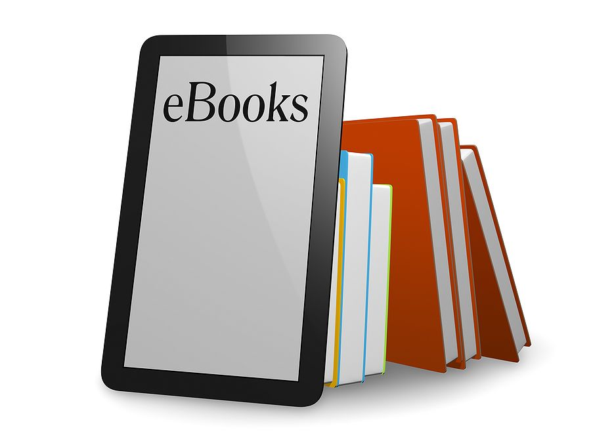

Do you sometimes wish to get into a bath with a good read in your hand? Then an e-Book is just what you need. The stress of possibly damaging the pages in a book taken out on loan is something that can be dawning. This is why Supreme Library offers e-Books on loan. If interested pop in at the library or contact the library at 021 522 1213.